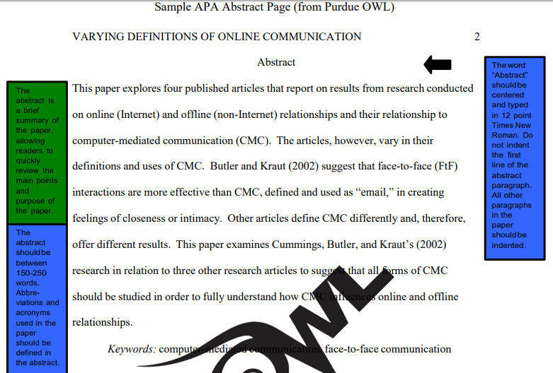
**Notice that sources ARE cited in the abstract and that it is a summary of your paper as a whole! Do not go into too much detail here.

References –
1. Your references should be on a page on their own. (If your paper ends on page 7, references go on page 8.)
2. The page should have the running head and page number like the others, and the title should be centered:
References
3. Your sources should be double-spaced and in alphabetical order, and you should use hanging indent. (I can show you how to do this if you need help!)
4. A web article APA citation goes in the following order (If it doesn’t provide the info, don’t include it):
Author, A. (Year, Month Day Published). Title of article. Retrieved from https://www.someaddress.com/full/url/.
Example Reference Page from Purdue OWL:

