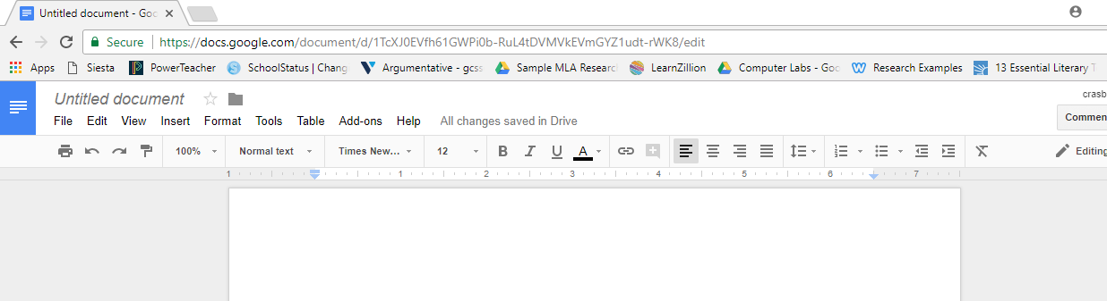
1. Font: Your paper should be 12 pt. font Times New Roman. Click on the down arrow for these two sections and the correct options will appear.
2. Spacing: Click the area circled in blue. The option for “Double” will appear. Choose that option.
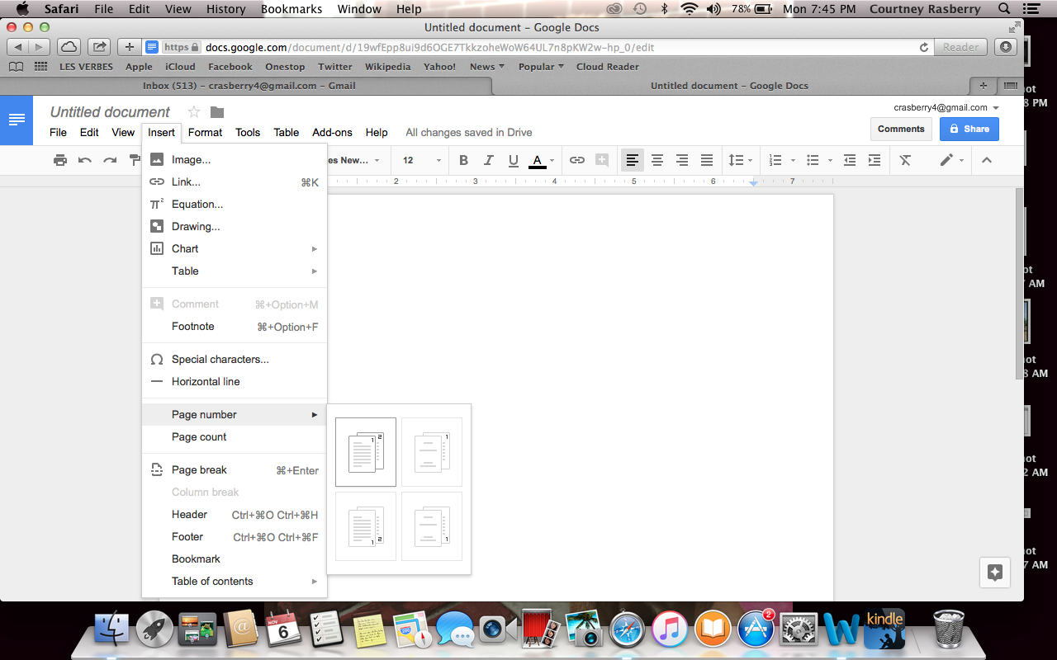
3. Header: Next, go to “Insert,” select “page number,” and the select the option chosen above. Edit the header by putting your last name to the LEFT of the page number (shown below.)
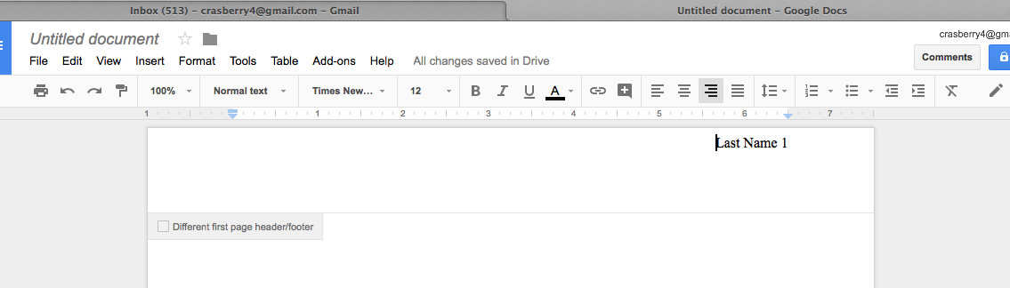
4. Once the page number is inserted, type your last name to the left of the page number (above).
5. Exit out of the header/page number and complete the following (green):
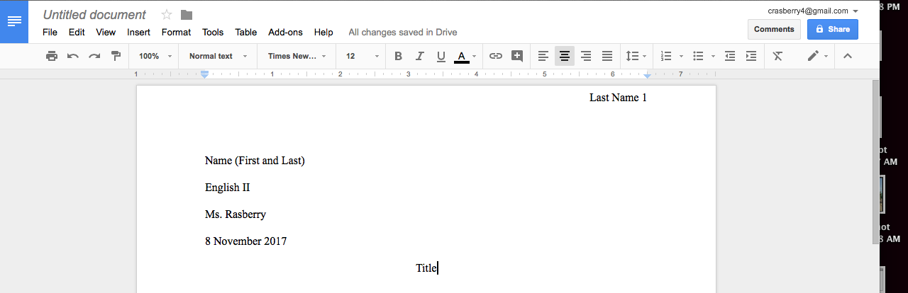
6. To center the title click the portion circled in blue. After typing the title, click the portion circled in red.
7. Type your essay. Be sure it is double-spaced and that you indent after each paragraph.
8. When you finish your essay begin a new page for the works cited page. Center the title: “Works Cited”. To indent correctly, use directions below.
First: click the area circled and move ½ inch
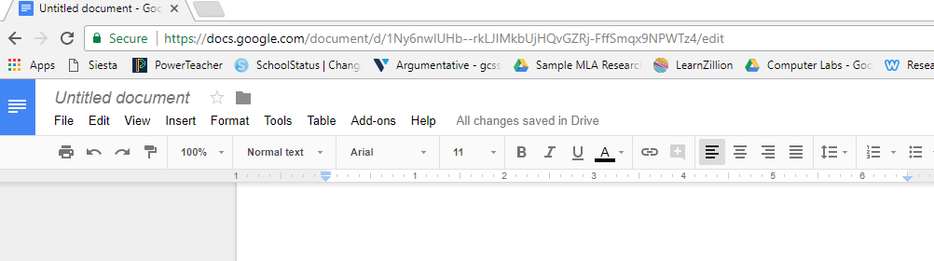

Both will move, but you will move the top portion back to its starting position.
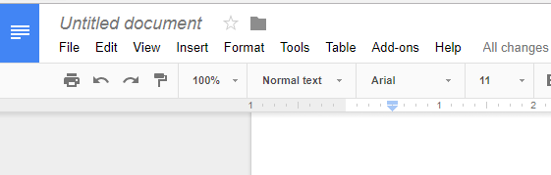
Finished, it should look like this:
